INVITATION
Security and Cultural Tour for International Students from
Korean War Participating Countries

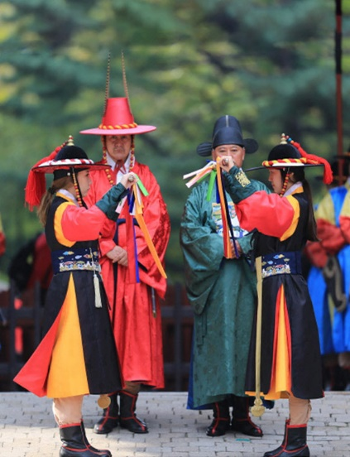
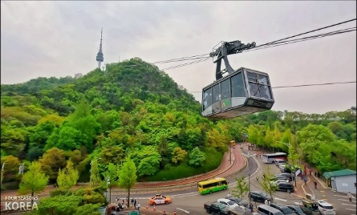
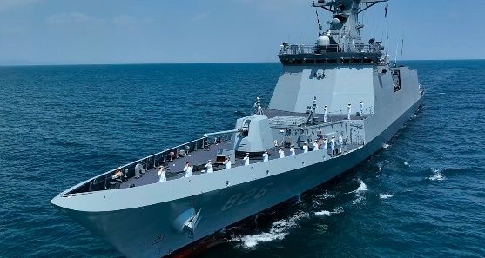
Discover history up close — a rare chance to explore a war-damaged navy ship (ROKS Cheonan)

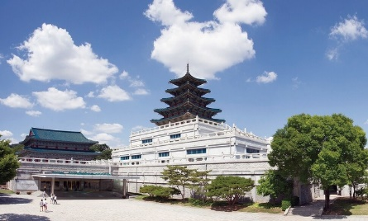

■ Take the Cable Car to the N Seoul Tower Observatory! ■ Watch the Spectacular Royal Guard Changing Ceremony at Gyeongbokgung Palace! ■ Exclusive Access to the World’s Largest Overseas American Military Base!
The People to People Korea National Headquarters is hosting a special two-day social program from June 24 (Tue.) to June 25 (Wed.), 2025, inviting international students in Korea from the 20 countries that participated in the Korean War. The event aims to share the importance of freedom and peace through security education and cultural experiences.
*** 20 Countries that participated in the Korean War: Australia / Belgium / Canada / Colombia / Denmark / France / Germany / Greece / Italy / Luxembourg / Netherlands / New Zealand / Norway / Philippines / South Africa / Sweden / Thailand / Turkey / United Kingdom / United States of America

Date | Program | Location
June 24 (Tue.) | Security Tour & Welcome Banquet | Naval Security Park of the ROK Second Fleet, Camp Humphreys (U.S. Military Base), The Golden Harbor Hotel in Pyeongtaek city
June 25 (Wed.) | Korean Cultural Experience | Gyeongbokgung Palace, National Folk Museum of Korea, N Seoul Tower
〇 Dates & Program Overview
- Note
June 24: Meet at 07:30 AM at Sadang Station Exit 4 (Line 4, Seoul Subway), Passport required
June 25: Program ends at 2:00 PM in Insa-dong
〇 Participation fee: Free of Charge
〇 Application Deadline: May 30, 2025
〇 How to Apply: Send the completed application form via email to ptpikorea@naver.com
〇 Contact Person: Soon Young Cho, Executive Manager, PTPI Korea National Headquarters
(Phone) 02-761-5241 (E-mail) ptpikorea@naver.com (Home) ptpkorea.or.kr

