NOTICE
Invitation to 2024 Autumn Course of Leadership Academy

Sunnong Culture Forum – a non-profit non-governmental organization - invites the students from developing countries to the 2024 Spring Course of Leadership Academy which opens on Friday, 8th of September.
Leadership Academy was created in September 2017 to share with foreign students studying in Korea successful Korean development experience from aid recipient to one of the global economic powers with strong emphasis on self-help spirit and a sense of ownership.
Leadership Academy also presents background information on key development issues commonly faced by developing countries in their efforts for national development such as mindset change, aid dependence, corruption, inequality, empowerment of women and leadership.
Contents of the Program are specially designed to promote the “Can-Do-Spirit” and nurture ownership and leadership for participating students who will become aspiring leaders of their own countries in the future.
Leadership Academy Program serves not only as a unique venue to share Korean development experience but also as an open forum to promote goodwill and friendship among participating students from many different countries.
The inaugural 2017 Autumn Course was completed with a great success. A total number of 35 students of 12 different Universities from 28 countries received the Certificates.
The 2018 Spring Course ensured more enthusiastic participation and awarded the Certificates to 43 students of 15 Universities from 31 countries who successfully completed the Course.
The 2018 Autumn Course had far more enthusiastic participation and awarded the Certificates to 58 students of 17 Universities from 29 countries.
The 2019 Spring Course had most enthusiastic participation so far, and awarded the Certificates to 63 students of 18 Universities from 40 countries.
The 2019 Autumn Course had far most enthusiastic participation and awarded the Certificates to 79 students of 17 Universities from 36 countries.
The 2022 Autumn Course had far most enthusiastic participation and awarded the Certificates to 72 students of 19 Universities from 39 countries.
The 2023 Spring Course had the most enthusiastic participation and awarded the Certificates to 90 students of 23 Universities from 48 countries.

The Course is conducted in English on every Friday 18:30 to 20:45 for 13 weeks with one time field trip. The participation is free of charge and there is no financial burden whatsoever to the students.
The 2023 Autumn Course had the most enthusiastic participation and awarded the Certificates to 97 students of from 44 countries.
The Course is conducted in English on every Friday 18:30 to 20:45 for 13 weeks with one time field trip. The participation is free of charge and there is no financial burden whatsoever to the students.
The due date of application is 1st of March 2024, the first lecture starts on 8th of March and the detailed information of the Leadership Academy Program including application procedure can be obtained at the homepage of the Leadership Academy (http://academy.sunforum.org)
If you have any inquiry on the Course, please send email to leadership2017@naver.com or call to Mobile 010-7390-3860.
Leadership Academy welcomes any student interested in understanding Korean development experience and being associated with other international students to its 2024 Spring Course.

Photos
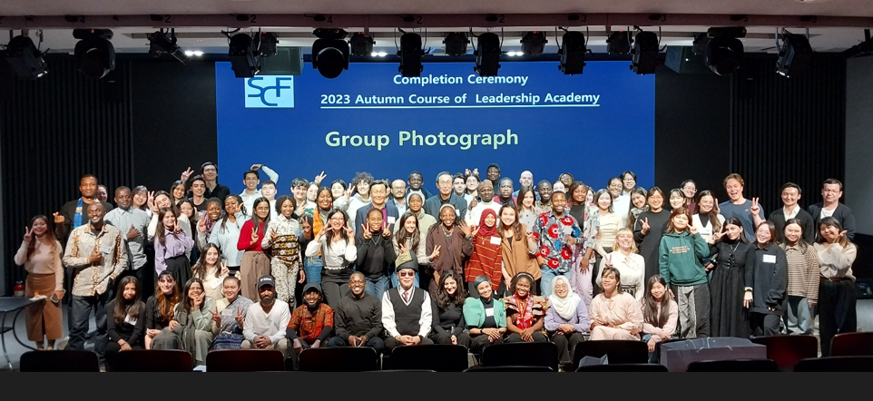
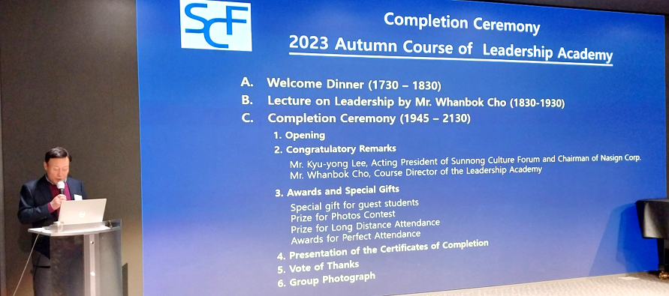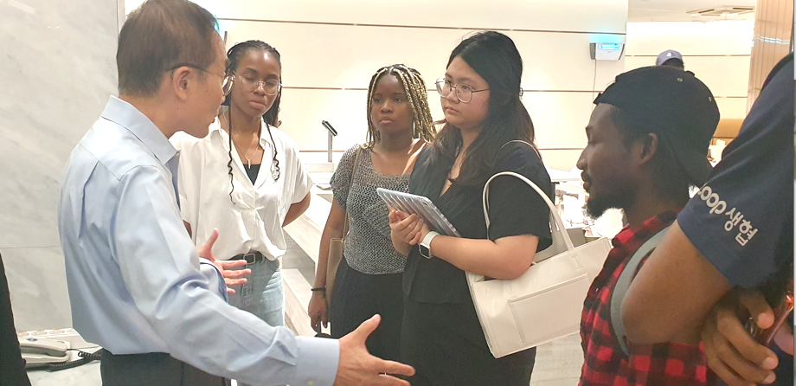
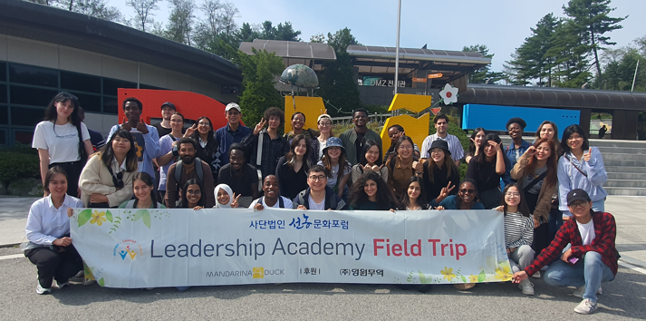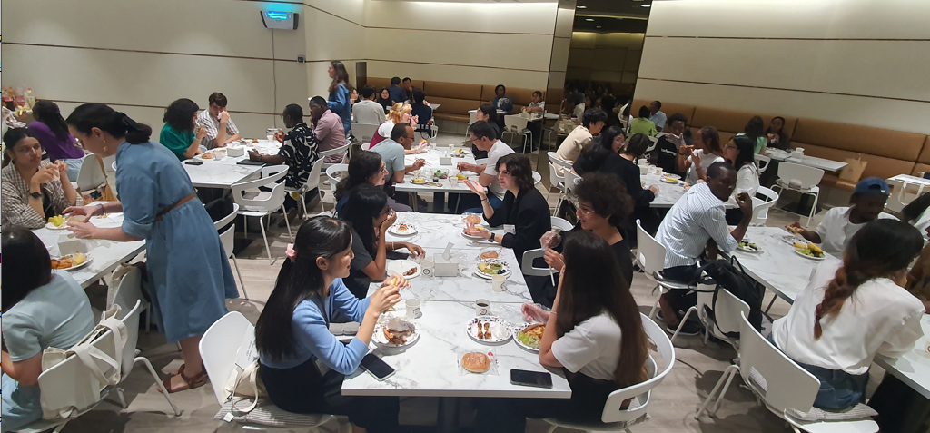

Composition of and Feedback from the Participants
2023 Autumn Course started on September 1 and lasted 13 weeks ending December 1. A total of 123 students applied the Program with final selection of 102. Out of them, 97 students from 44 countries received the Certificates of Completion. Composition of 97 students is as follows:
A. By sex
- Male 33, Female 64
B. By continents
- Asia and Pacific
48 students from 19 countries / Uzbekistan (6), India (5), Vietnam (4), Laos (4), Malaysia (4), Mongol (4), Philippines (4), Cambodia (3), Bangladesh (2), Kazakhstan (2), Turkmenistan (2), Azerbaijan (1), East Timor (1), Indonesia (1), Myanmar (1), Pakistan (1), Taiwan (1), Thailand (1), Turkey (1)
- Africa
27 students from 11 countries / Ghana (8), Nigeria (6), Kenya (3), Uganda (2), Morocco (2), Algeria (1), Burkina Faso (1), DR Congo (1), Ethiopia (1), Mozambique (1), Rwanda (1)
- Latin America and the Caribbean
13 students from 9 countries / Brazil (3), Peru (2), Mexico (2), Argentina (1), Bolivia (1), Colombia (1), Ecuador (1), Dominican Republic (1), Jamaica (1)
- Europe / USA
9 students from 5 countries / Serbia (3), Russia (2), Germany (2), France (1), Austria (1)

C. By University
Total 20 Universities:
Seoul National (16), Korea (14), Sogang (11), Hanyang (8), Yonsei (7), Sungkyunkwan (7), Kookmin (6), Ajou (5), Hankuk University of Foreign Studies (4), Ewha Women’s (3), Korea Aerospace (3), The Academy of Korean Studies (2), Konkuk (2), Dongguk (2), Inha (2), Chung-Ang (1), Soongsil (1), Korea at Sejong Campus (1), Semyung (1), Hannam (1)
D. By level of study
Undergraduate level (30), Master degree level (61), Doctoral degree level (6)

2. Feedbacks from the participants
A. Students from Asia and Pacific
- The program was informative during the last 13 weeks. I learned so many leadership qualities that will help me become a good citizen for my country.
- I personally feel grateful for the opportunity of attending this leadership program. It’s a great honor and I learned a lot from the lectures. I enjoyed every topic of lecture and thank you for always feeding us with all the snacks and food. Overall, the program is well-equipped and informative especially for us, University students.
- First of all, I would like to say much thanks because of making such informative and supportive program for the international students. Secondly, as an international student(s) we learnt much about Korean society, policy, business, development story and so on. Mainly, we made many global friends all over the world. Such informative leadership programs cost much, but we studied totally free of charge and plus snacks with drinks.
- My general observation is that this leadership program is very informative and motivational. I believe that students from developing countries really got idea of development and like the debates and discussion going around this topic.
- The program was highly insightful and fun. The guest speakers were all very passionate about the topics they spoke about and their passion made hearing the lectures exciting. This program brought a variety of issues to light and addressed them appropriately and with sensitivity.
B. Students from Africa
- This program was more interesting, informative and well organized than I expected! I would highly like to recommend my friends to this program! These were the best 13 weeks in Korea.
- I am very glad to get this opportunity. Meeting new people and enriching my knowledge about Korean economy and many other fields. Thank you for your time and kindness.
- This program is highly informative, mind opening and rich in diversity. All professors were very articulate. The venue is easy to access through subway and bus. The organizers were kind and accommodative.
- As a student and citizen of a Commonwealth developing country, I am empowered and I will pass on this knowledge to the next generation of people under my leadership back home, sharing the success of South Korea and encouraging them that they can indeed be successful.
- The program was highly informative! I usually never get opportunities to meet other GKS scholars and international students in other schools than my own, so this was a great opportunity to interact with my fellow scholars.
C. Students from Latin America and the Caribbean
- I think the program was well organized. It always started on time and the presenters brought new information to the audience. The schedule and contents of the presentation were right.
- I really enjoyed the program. It was interesting to learn several topics that can help me to reflect how can I help my country to develop with the inspiration of Korean development in mind. Also, even though I’m not from technology field, it was good to learn about data, science, industry and much more.
D. Students from Europe
- I enjoyed the program quite a lot. I think that having discussions about these topics and listening to the opinions of others all around the world after each lecture was very informative.
- I felt very much supported and motivated after the lectures and I was able to hear lectures on many different topics from people I would not have a chance to experience otherwise.
- I found it really informative and inspiring. I feel like I made a lot of knowledge that I will use in the future.

