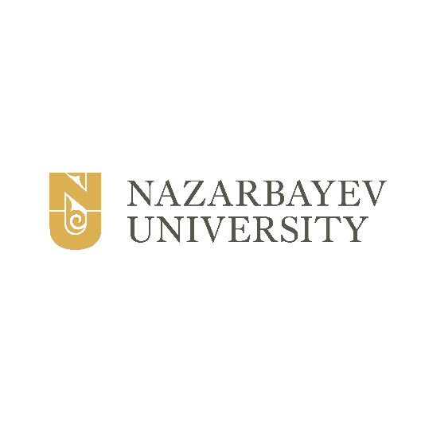


AUA Youth Forum 2020 ─
Building a Meta Silk Road: integration of Asian cultures in the real and virtual universe

24-29 October 2022

Host:
Nazarbayev University
Nur-Sultan city, Kazakhstan

APPLICATION FORM

(Passport Photo)

PERSONAL INFORMATION
Full Name (as in passport)
Gender (M / F) |  | Date of Birth
Contact Number (Mobile)  (country code – area code – tel no.) |  | Email Address
Nationality |  | Home University
Mailing Address
(Country, City, State/Province, Zip/Postal code, Address)
Dietary requirements |  |  | Accessibility requirements
EDUCATION INFORMATION
Name of Home University
Faculty/School/Department
Year of Study |  | Level of Study
Major |  | Minor (if applicable)
NEXT-OF-KIN (to be contacted in case of emergency)
Full Name (as in passport)
Relationship |  | Home Address  (Country, City, State/Province, Zip/Postal code, Address)
Contact Number (Home)  (country code – area code – tel no.) |  | Contact Number (Mobile)  (country code - area code - tel no.)
Email Address
OFFICIAL CONTACT PERSON AT HOME UNIVERSITY
Name | AHN SIHUN
Position | Manager | Email Address |  |  | ahnsihun@snu.ac.kr
Telephone Number  (country code – area code – tel no.) | 82-2-880-8636 | Mobile Phone Number  (country code – area code – tel no.) |  |  | 82-10-4609-7188
Mailing Address | International Center (Bldg. #152), Seoul National University, 1 Gwanak-ro, Gwanak-gu, Seoul 08826 Republic of Korea
WHAT DO YOU EXPECT FROM THIS PROGRAM?
KINDLY PROVIDE A BRIEF DESCRIPTION ABOUT YOURSELF

